BAY STREET ONE CONDOMINIUM ASSOCIATION
c/o Neighborhood Association Management, Inc.
P. O. Box 10968
Pleasanton, CA 94588

(925) 243-1797

Fax (925) 243-1798

apulizzi@neighbhorhoodam.com

February 11, 2019

Re: Garage Floor Cleaning Schedule

Dear Residents,

As part of an ongoing effort to improve the level of cleanliness around the property, your Board of Directors and management team will implement regularly scheduled garage floor cleanings, starting March 1, 2019.

This cleaning will cover all areas of the garage, including your assigned spaces, guest spaces, drive aisle, dead/storage spaces, and more.

Cleaning Schedule

The garage will be cleaned twice during calendar year 2019:

- First cycle - March 1 through July 24
- Second cycle - July 26 through December 20

Cleanings will take place every Wednesday and Friday, between 9 a.m. and 1 p.m. Individual spaces will be cleaned on a predetermined schedule.

The 2019 schedule is attached for your review. Please look for your space number in both tables (Cycle #1 and Cycle #2). Please take note of the date that your space is scheduled to be cleaned.

Moving Your Vehicle

Prior to cleaning, you will be required to move your vehicles out of the garage or into a designated reserved guest parking space.

We have set aside guest spaces #102 to #107 for the use of the residents affected by that day’s cleaning, from 9am to 1pm.

If your cleaning happens to fall on May 29 or June 12 when we double our cleaning efforts, we will also have guest spaces #108 to #112 and #121 reserved for your use as well.

Please note that existing guest parking policies will remain in effect. Your vehicle should be moved prior to and following the cleaning – ideally, in the morning of the cleaning day to the guest spaces and in the evening after the cleaning back to your assigned parking space.

Additionally, please remind any visiting guests not to park in these reserved spaces during the cleaning days/times. Designated spaces will have the appropriate signs posted.

Residents who do not move their vehicles on their assigned cleaning day will be subject to citation, hearing, fine, or towing. If you have an extenuating circumstance, please see the “alternative arrangements” section below.

Outdoor Storage Unit

Once a year, you will be required move your outdoor storage unit from your space, so we can clean underneath it and perform a surface inspection.

For 2019, this will take place during the initial cleaning cycle (Cycle #1, March through July).

Before your scheduled cleaning, please move your storage unit to the open area in front of disabled parking spaces #39, 40, 210, or 211. Please note the following:

- When moving, do not drag your storage unit across the garage floor, as it will damage the garage surface coating.
- Instead, please utilize the flatbed trollies located front of disabled parking space #101 to move your storage unit.
- Do not simply shift your storage unit to a dead space adjacent to your parking space, as that area will be cleaned as well on your cleaning day.
- Do not block any of the painted clearance areas around the disabled parking spaces, as they must be kept clear.

You do not need to move your storage unit during cleaning cycle #2 (July through December). However, if you wish to have the area beneath your storage unit cleaned during cleaning cycle #2, simply move your storage unit to the open areas noted above prior to your scheduled cleaning/date time.

Similar to the procedures for moving your vehicle, we ask that you move your storage unit immediately before your scheduled cleaning and move it back immediately after.

Please see the diagrams below for where to place the storage units on your cleaning day.

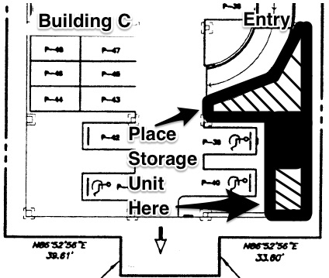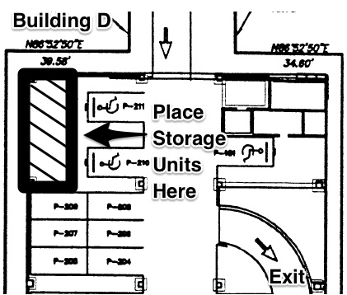

Alternative Arrangements

We understand that you may have extenuating circumstances or unique situations that may not work with this cleaning schedule (i.e. extended vacation, etc.). Please contact me as early as possible to let us know of your situation and we can try to work around it on a case-by-case basis. However, please contact me no later than one week prior to your cleaning day.

Unless an alternative arrangement is made prior to your cleaning day, all residents who leave their vehicle in their assigned spots on their designated cleaning day will be subject to citation, hearing, fine, or towing.

Summary

I understand that this is a big change from our prior year’s cleaning procedure. However, we are confident that this will increase the level of cleanliness of our garage and the integrity of the surface coating on the floor.

Please contact me with any questions you may have. Thank you for your understanding and cooperation.

Sincerely,

Andrea Pulizzi
Property Manager

FAQ

- Why is this change being made?

Previously, spaces were cleaned on a random basis, when the space was unoccupied. Unfortunately, this led to many parking spaces being missed.

- Why aren’t we doing once-a-year cleanings, as in year’s past?

Once-a-year garage cleanings were only beneficial in that we would be able to clean the parking garage in one day.

However, the HOA incurred significant costs in hiring an outside vendor to perform this work – not to mention the disruption of having all residents move both of their vehicles out of the garage on a single day.

In 2017, the HOA acquired our own floor cleaning machine so we could progressively clean the garage floor throughout the year at a lower cost.

However, as previously mentioned, not having a scheduled cleaning routine has hampered our ability to maintain a high level of cleanliness in the garage.

- Why does my parking space need to be cleaned so often?

As our building ages, we must better maintain the surface coating on the garage floor. This is a delicate surface that is very expensive to repair and reapply.

By cleaning and inspecting the coating twice a year, we are able to better assess the condition of the surface coating more regularly. This approach also helps us more quickly recognize and remove damaging automotive chemicals that seep onto the floor.

